

www.globalchallengecharity.com

GLOBAL CHALLENGE CHARITY FUNDRAISER – FAMILY VARIETY SHOW ENTRY FORM

Thank you for your interest in being one of the acts for our fun Charity Family Variety Show on Sunday 16th May at 4pm. The show will take place virtually on YouTube and we are asking acts to send us pre-recorded videos of their performance to play throughout the show. This is a chance for individuals or groups to entertain us and shine, while raising money for much needed medial health services and special needs equipment in Uganda.

You could sing or dance, you may want to show us your art, a magic act, create a short drama, a rap, play a musical instrument, or be a comedian. Get your creative juices flowing and start making your video. It is free to enter your video.

If you have any questions about making or submitting your video, please contact the team at globalchallengecharity@qrbc.net.

PLEASE READ THE TERMS AND CONDITIONS BEFORE SUBMITTING YOUR VIDEO.

Name of Participant (s):

Telephone of main contact (parent/guardian if participant under 18): _____________
Email of main contact (parent/guardian if participant under 18): _________________
Solo Act/Group Act (please delete as appropriate)
Talent Description:

Name of Parent/Guardian if child is under 18:

Permission given to use your video at a future variety event. Please delete as appropriate. YES/NO

ENTRY FORMS AND VIDEOS ARE TO BE SUBMITTED BY FRIDAY 9TH APRIL.

Please follow the instructions below on how to video your act and how to send it to us using WeTransfer.

Your video should be no longer than 3 minutes.

TERMS AND CONDITIONS FOR THE ONLINE VARIETY SHOW

- We will contact everyone who submits a video for the show. We cannot guarantee to include all videos submitted. This may be due to an overwhelming response. Therefore, we hope to use any unseen videos at an event in the future.
- We reserve the right to edit the length of the video to fit with the overall program timings.
- Parental consent will be required for any videos including children for safeguarding purposes.
- We reserve the right not to use any videos that have inappropriate content for a family Variety Show.
Below are some general guidelines to help you with the recording process and ensure we are doing the same thing in how we record our video.

Device / Filming
- If you are using a mobile phone, please film in landscape/widescreen only.
- Once the recording starts, please leave a few seconds before you start to speak. Record your content and once you finish please pause for a few seconds (still looking at the camera lens) before ending the recording.
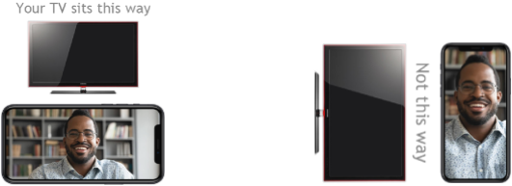

Image / Framing

- Please don’t hold your device or have it hand-held by someone else, as no matter how hard you try there will be a wobble.
- Please make sure that your device is propped up sufficiently for the camera to be at

eye level.
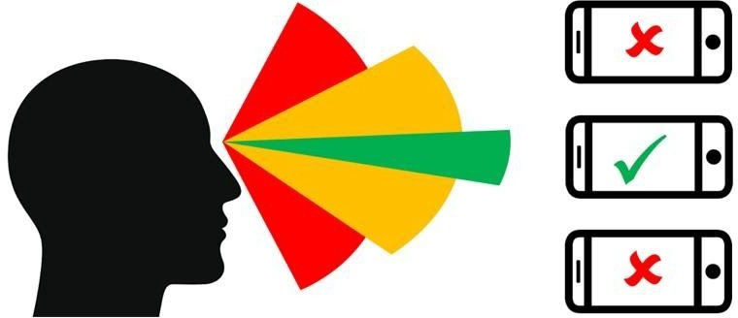

- Position yourself at a distance from the screen so that it’s just your face and torso in the shot.
- Please don’t stand too far back as this will affect the sound quality.

Lighting

- Please try to use natural light.
- Please avoid direct sunlight on the lens of the camera and on your face.
- If you are unable to use natural light, then please light your face evenly with a lamp
when recording, not just lights from a ceiling which will likely cause shadows.

Audio

- Please be no further than 1.5 metres from the device and speak loudly and clearly
so it can pick up good audio.
- Please watch out for any hums or other background noise that may be going on around you.
- Avoid rooms with too much echo like a large kitchen or large room with a hard flooring/surfaces. A room with lots of soft furnishings will help with sound a lot

File Delivery

- Please send us your completed form and video via WeTransfer (https://www.wetransfer.com/) to globalchallengecharity@qrbc.net email. This is to ensure we have high quality files. Please write your name, talent description and email address in the transfer message box.
- Please do not use WhatsApp as it will degrade and compress the video quality.
- Please only send us only the “raw” file using the above suggested transfer methods.
- Please do not modify, edit, process or adjust the original files.

We are committed to protecting and respecting your privacy. The personal information you are giving us will only be used to communicate with you about the Charity Variety Show. You have the right to withdraw consent of your information at any time by contacting globalchallengecharity@qrbc.net.

